**CS 5551 Second Increment Report** Adam Carter

Class ID: 9, Project Group ID: 1

CS 5591 – Spring 2015

1. **Introduction**

This is the summary report of the second iteration of work performed on the Terrapin Collection Manager system. This system proposes to implement a framework for organizing and managing a user’s Board Game collection. The full background of this project can be found in the Project Proposal Document [1] submitted previously.

For this second iteration, my primary focus to begin the iteration was on the agent process and improving the process for fetching and then approving game content. While not complete, this process took longer than expected due to a high degree of variation and inconsistency in the data. Focus then shifted to the Services tier, where User and Collection services were implemented. Finally, the last few days involved finally performing some front end work and creating an initial set of web pages.

Since many of the details behind the architecture of this system were discussed previously in my Project Plan [2] and elaborated on during the First Iteration [3], I will not be repeating elements of those discussions here except to discuss changes or additions.

1. **Objectives**

The objectives of this iteration, given where last iteration ended, were to solidify the external data pull operations, prepare that data to be analyzed and converted into Game objects, then associated the other external sources via matching to the Game.

Roughly the first half of this iteration was devoted to this process, with most of the code changes coming in the Agent layer, supported by corresponding changes to the ac-games-pojos project as new issues were discovered. To put some numbers into perspective:

Total number of Games listed on BoardGameGeek I am tracking: 158536

Total number of Vendor entries I am tracking: 146429

Because of the scope, I spent a fair amount of time working on building some intelligence into the processing effort, determining which entries were invalid or incomplete, which items are capable of being ignored (for example, entries for game supplies instead of games), and attempting to automatically process and confirm as many entries as possible. This effort is still in flight, but so far I have been able to review more than 93% of BoardGameGeek entries and developed a means of categorizing Vendor data that should help during the automated matching work.

Since some of that work can only be done manually, I turned my attention to the UI, rather than try to do all that work by hand. However, prior to being able to work on that interface, I realized I needed to build out the services to support not just Game and GameReltn data, but also Users to support login and permissions, which then led to the need to implement Collection data to complete the User object and it’s child classes. Most of the second half of this iteration was spent building out the required REST service endpoints, which will be discussed later.

Finally, the last four days I have been finally diving into HTML5 and Bootstrap to work on developing a UI. I was able to create a home page, about page, and login and signup pages to move forward, but those pages allowed me to learn a lot more about HTML5 and Bootstrap in particular. This time will be very valuable moving forward in the remaining iterations.

1. **Design Overview**

Fundamentally, there have been no significant changes to the overall architecture of the system. This iteration was really more about expanding capabilities than exploring design issues, with the exception perhaps of the web pages. Much of the planning on how new services should be implemented has been done previously.

One change I did make was to change the structure of my web pages to move away from a single page model where multiple pages are specified as page content in the HTML body and instead created separate HTML pages for each required page. There were issues I encountered related to how the page separation was being handled (or not handled). This forced me to consolidate libraries, generating a single common .css file for all related pages, and has resulted in some level of duplicated code, but has the tradeoff of being cleaner to manage events and reduced page load times due to javascript tasks that are required in some instances to run at page load.

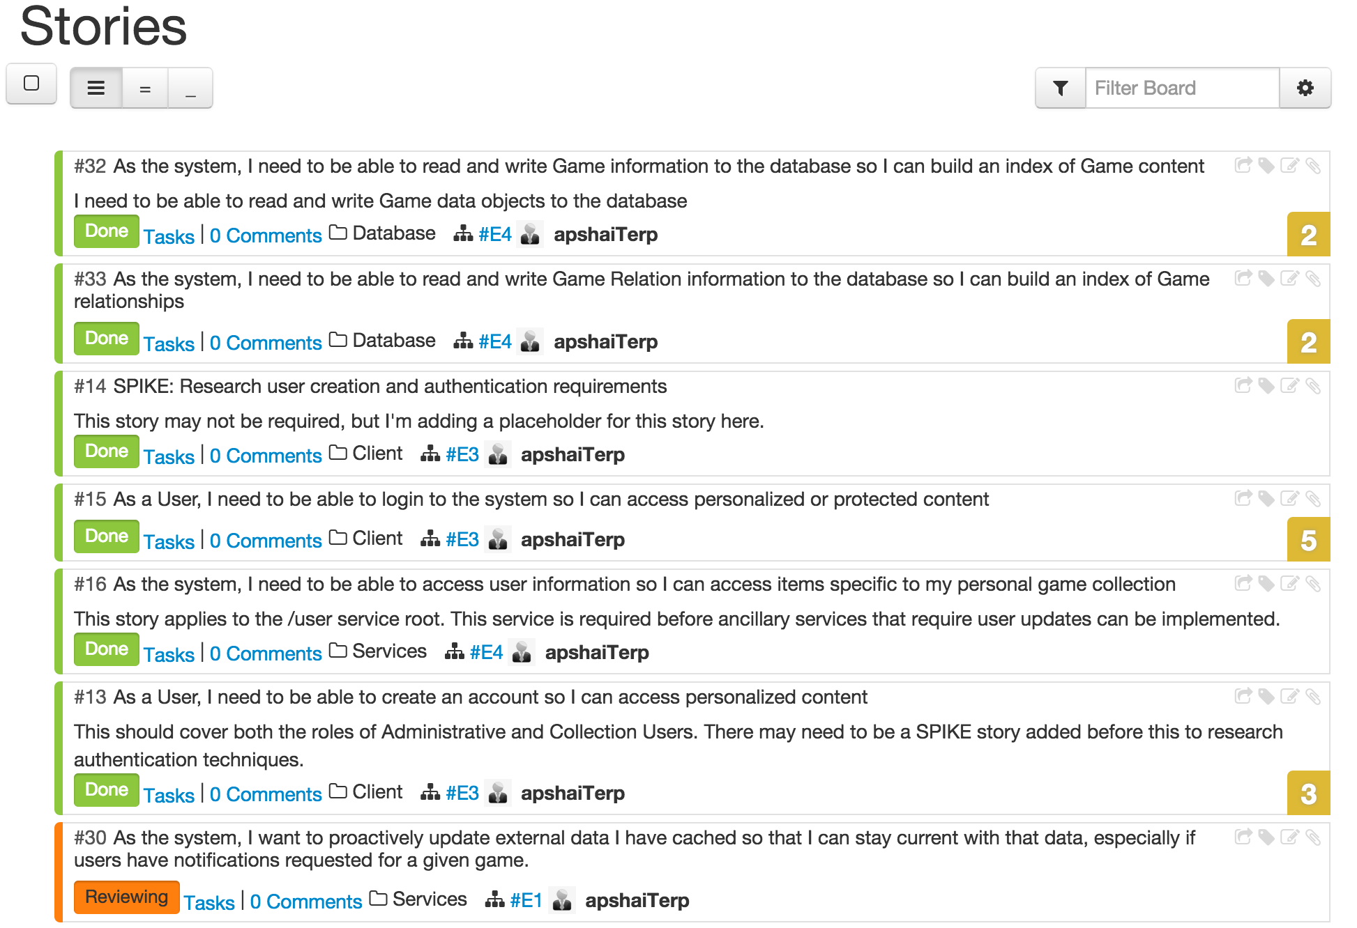

From a story perspective, 6 stories were completed, with one close to completion, and another 5 stories were begun, but not completed, which will be rolled into the third iteration.

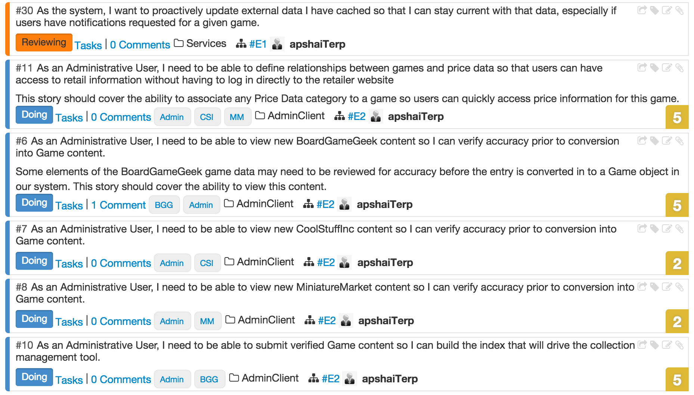

The backlog currently contains another 15 items. Many of those stories are related to the front-end HTML pages that will need to be developed that could not even be attempted without the services implementation I have been working on thus far, and I expect many of those tasks to be accomplished reasonably quickly, so at this point, I still feel confident I will be able to deliver on all the stories planned.

Finally, on the topic of design for the HTML pages, I have settled on some common elements, that I intend to use to bind the Look and Feel of my site together. There will be a navbar element at the top of the page, followed by a large visual component referred to by Bootstrap as a Jumbotron. There are also common themes of Terrapin images and a background image that all pages share that is defined in the common .css file to be shared by my HTML pages. Examples of this will be shown later in the Implementation discussion.

1. **Implementation Details**

To begin presenting what has been implemented during this iteration, I want to present some quick statistics that were generated to give an idea of progress made. Eclipse has a number of plugins that can generate code statistics driving off any number of criteria. For clarity, I will be presenting statistics in the following 4 categories: Number of Classes, Number of Tests, Total Lines of Code (TLOC), and Meaningful Lines of Code (MLOC – A measurement that ignores whitespace and commented lines).

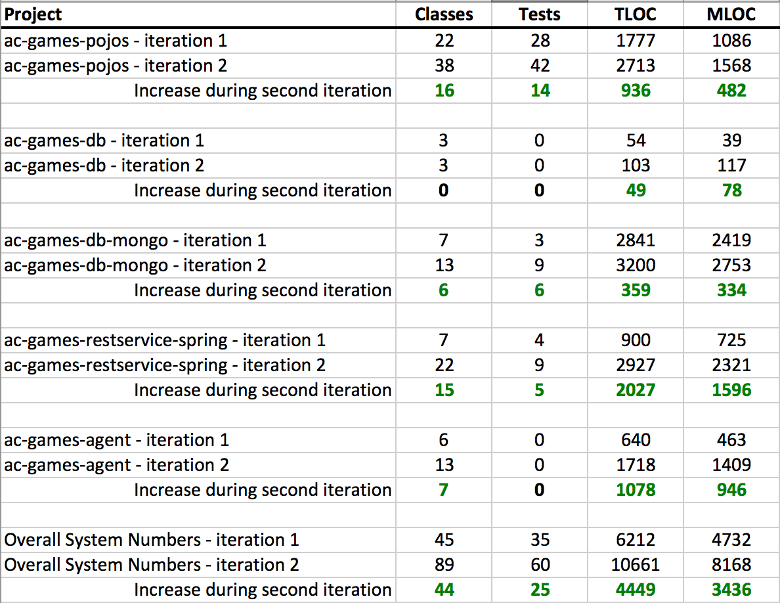

This data summary illustrates clearer than a lengthy discussion how progress has been made in all major project components. There was more work done in the Mongo space than is truly reflected in the line counts, since I was able to simplify a handful of operations by refactoring and genericizing a handful of calls.

The REST service grew the most from a raw amount of code perspective. During this iteration I implemented the following new REST service endpoints with full CRUD support (GET, PUT, POST, DELETE) unless otherwise indicated.

**/game**

**/gamereltn**

**/user**

**/collection**

**/collectionitem**

**/login** (Only supports POST for performing login operation, and PUT for updating sensitive user data)

All 6 of these new services, with their corresponding data objects and validation requirements were done this iteration.

The only major implementation detail that differs from earlier implemented services is that in some cases there are cascading effects of some data changes, for example, if I remove a User from the system, I must also remove his collection and every item in his collection from the system as well.

For reference, the code repositories for each project are listed below. All code for this release has been checked in to the Master branch of each project. Because class diagrams at this point are a little large to make inclusion in this document meaningful, they have been uploaded as part of the github project under the src/model folders.

* **ac-games-pojos** – <https://github.com/apshaiTerp/ac-games-pojos>
* **ac-games-db** – <https://github.com/apshaiTerp/ac-games-db>
* **ac-games-db-mongo** – <https://github.com/apshaiTerp/ac-games-db-mongo>
* **ac-games-restservice-spring** – <https://github.com/apshaiTerp/ac-games-restservice-spring>
* **ac-games-agent** – <https://github.com/apshaiTerp/ac-games-agent>

Finally, the last element I want to discuss is the HTML development. All development for this project is being checked in to <https://github.com/apshaiTerp/agent-site>. Included below are some screen shots from both the Standard Web view, as well as Mobile.



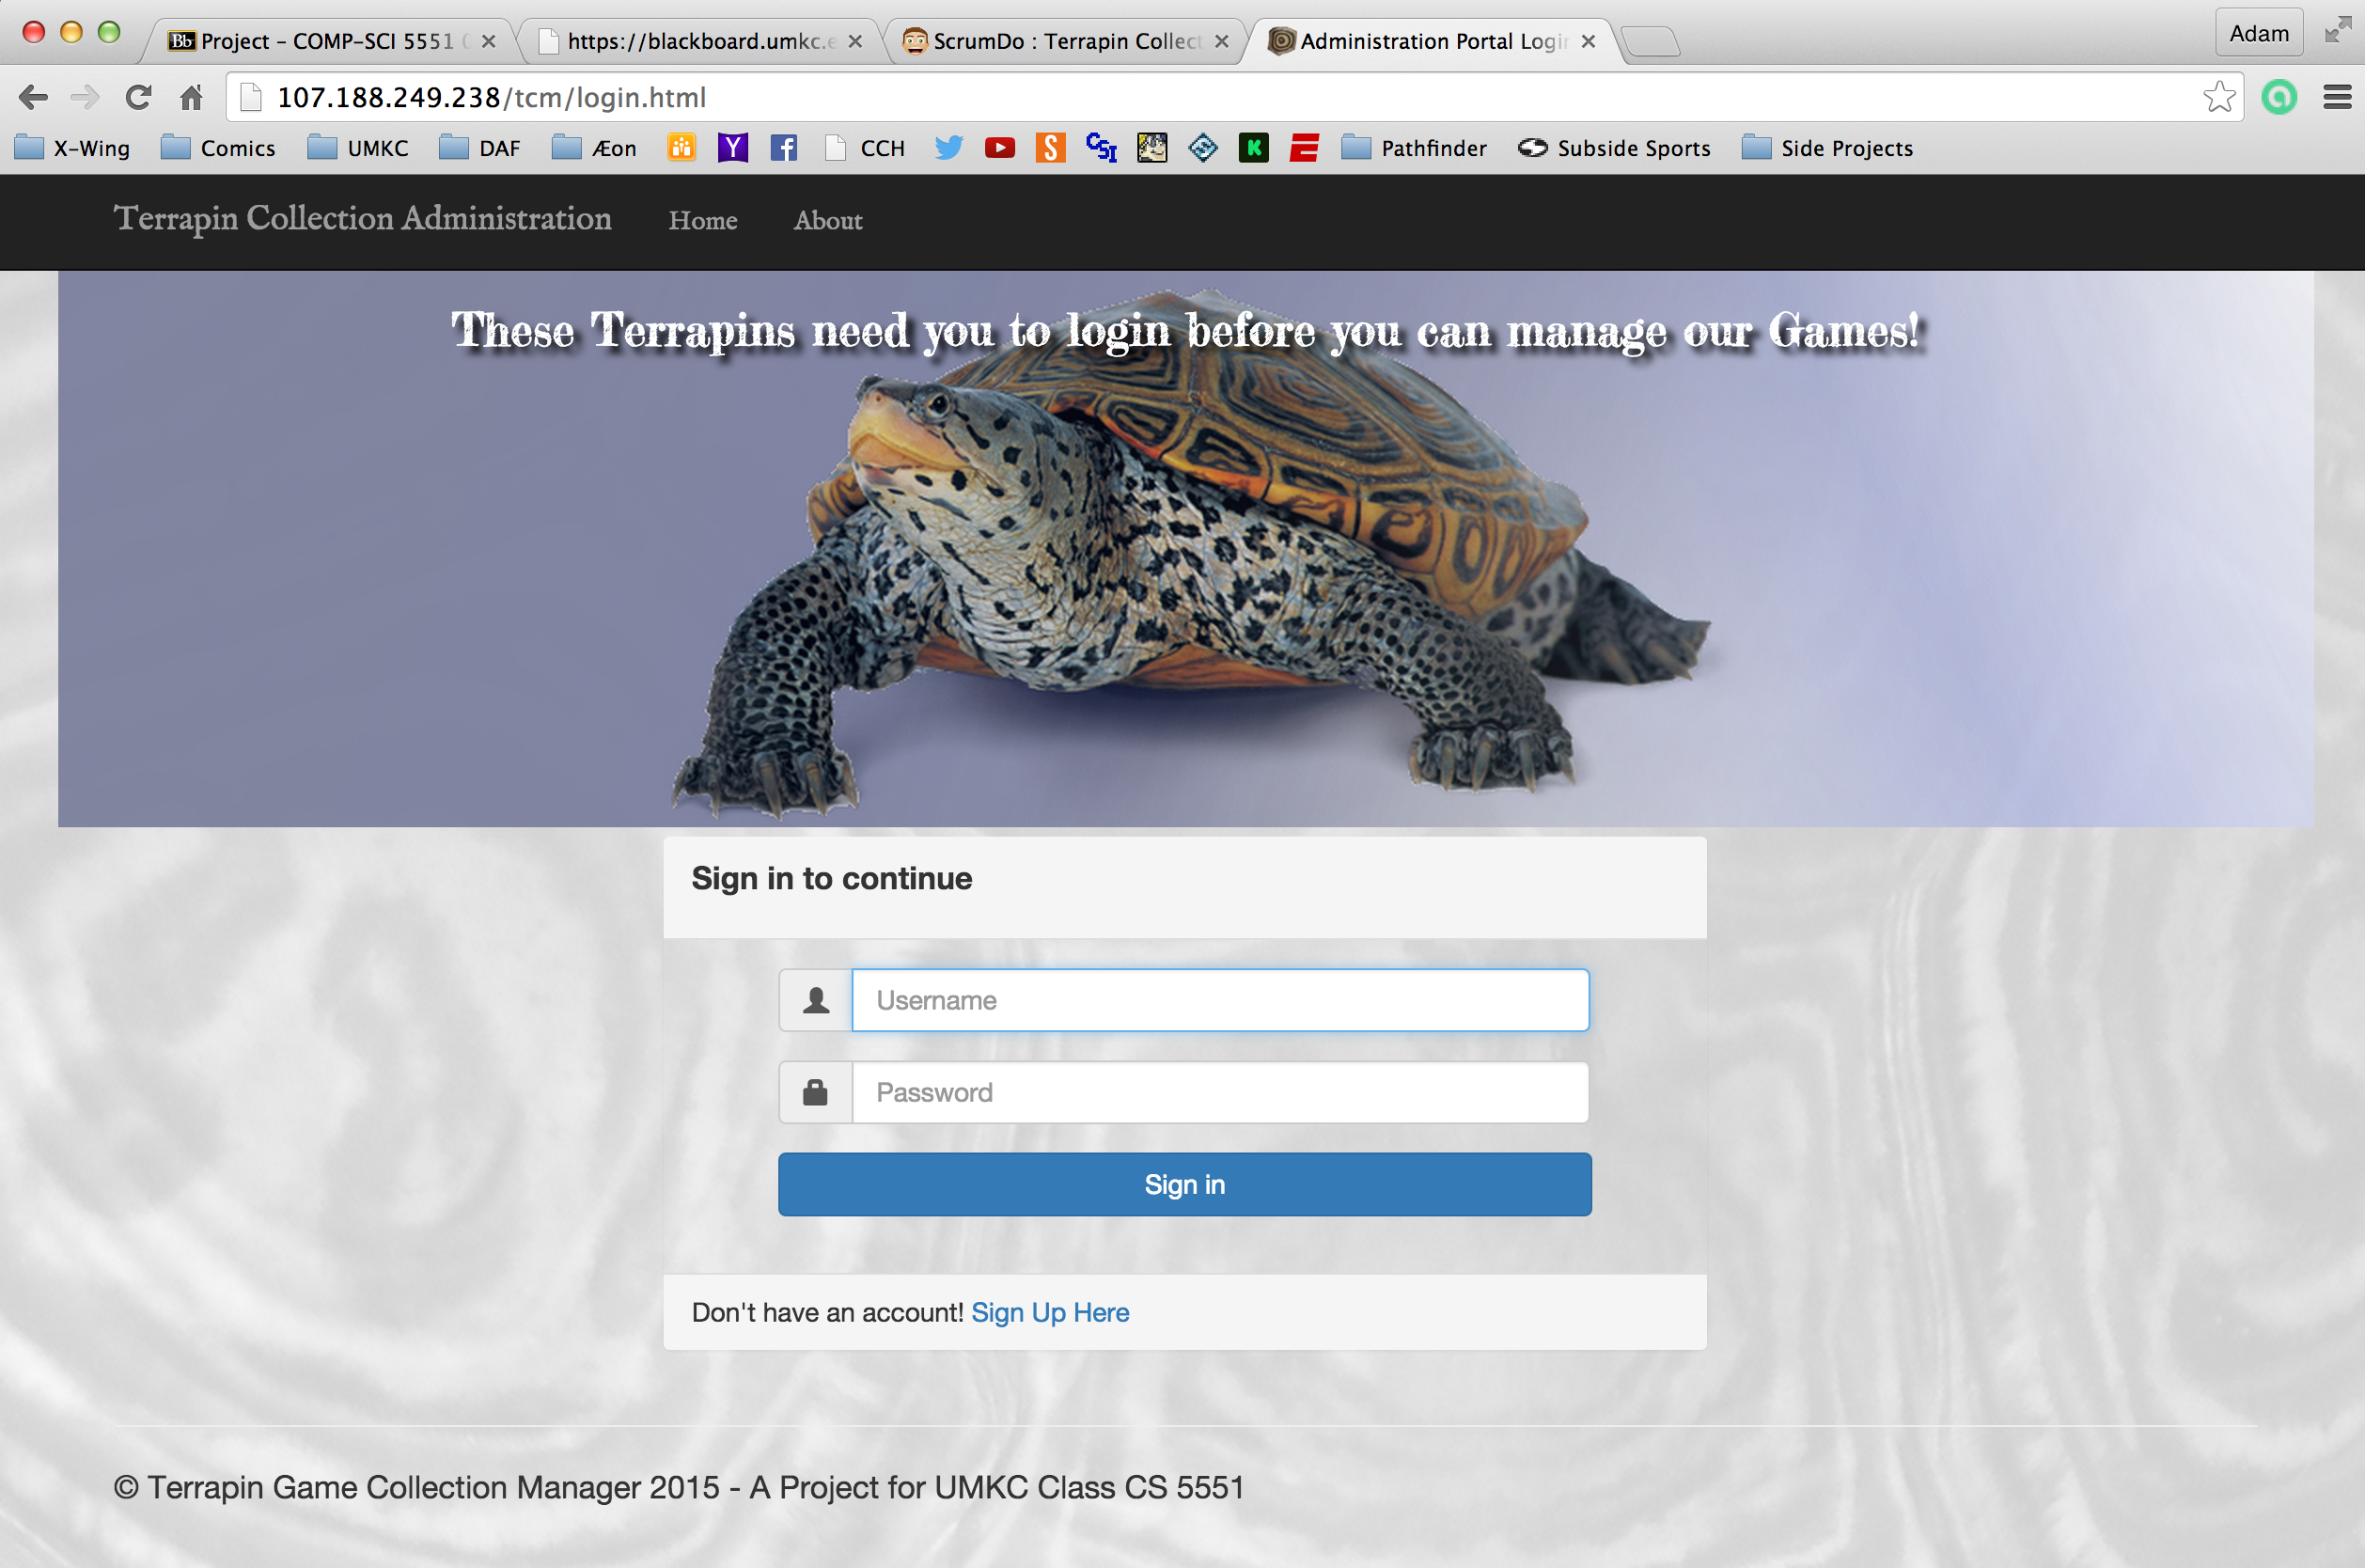

 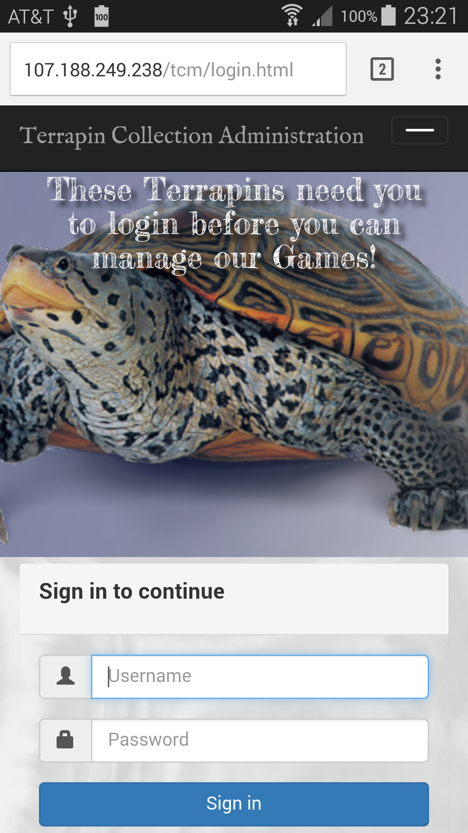

As the screen shots show, by using Bootstrap I was able to implement a responsive design that if not always as clean as the full browser version, is functional and scales all the elements appropriately.

1. **Testing**

Unit testing was expanded quite a bit with this iteration, though the ac-games-agent process is still without Unit Test.

The important tests I focused on were ensuring that objects behaved correctly, that the REST calls were processed correctly, and that the database operations processed data correctly. All of those tests have been implemented. As with the last iteration, I am including the surefire and clover reports, which have also been uploaded to my documentation site for this iteration. The Code Coverage percentages are lower than the true test coverage numbers because the tests aren’t all running through a single source. It is possible to do it this way, but the maven configuration necessary has not been a priority.

* **ac-games-pojos**

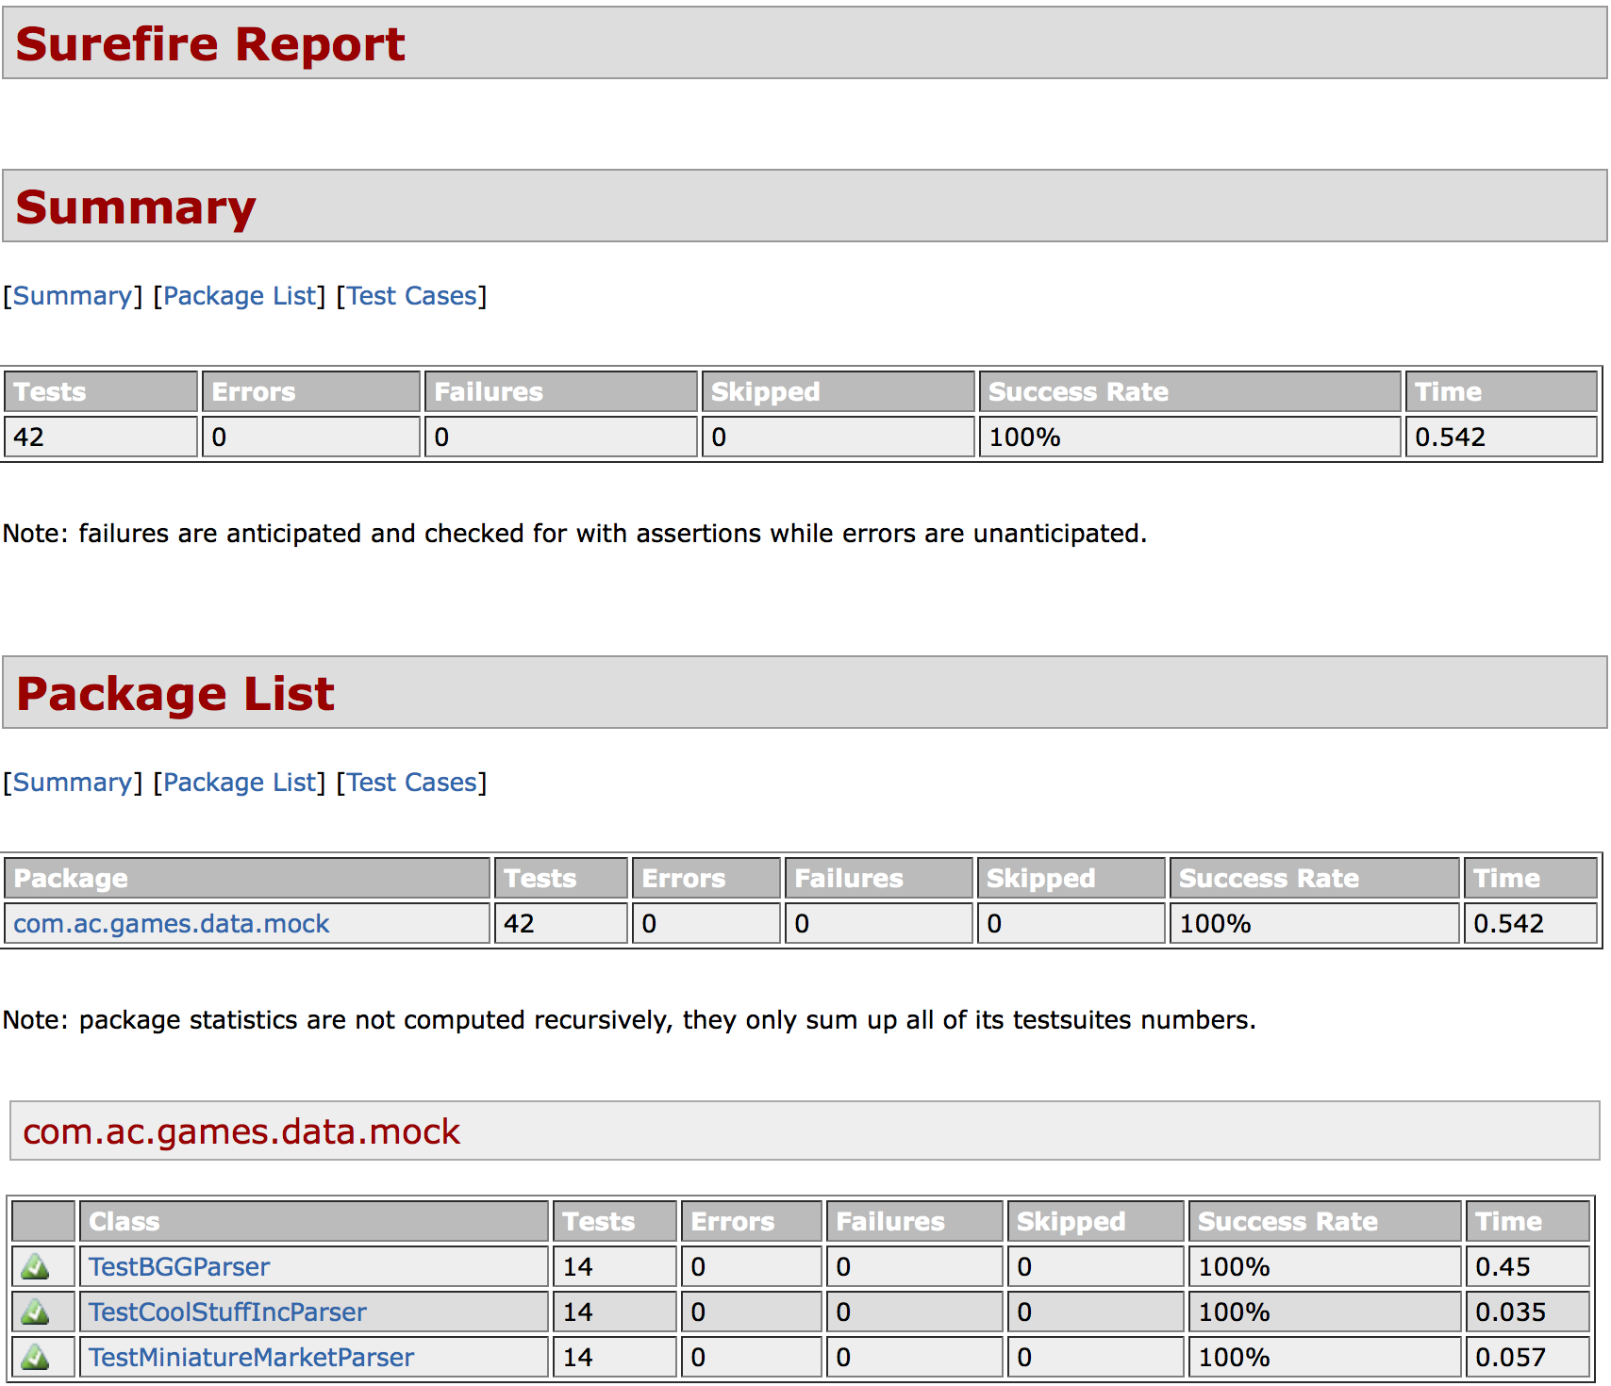

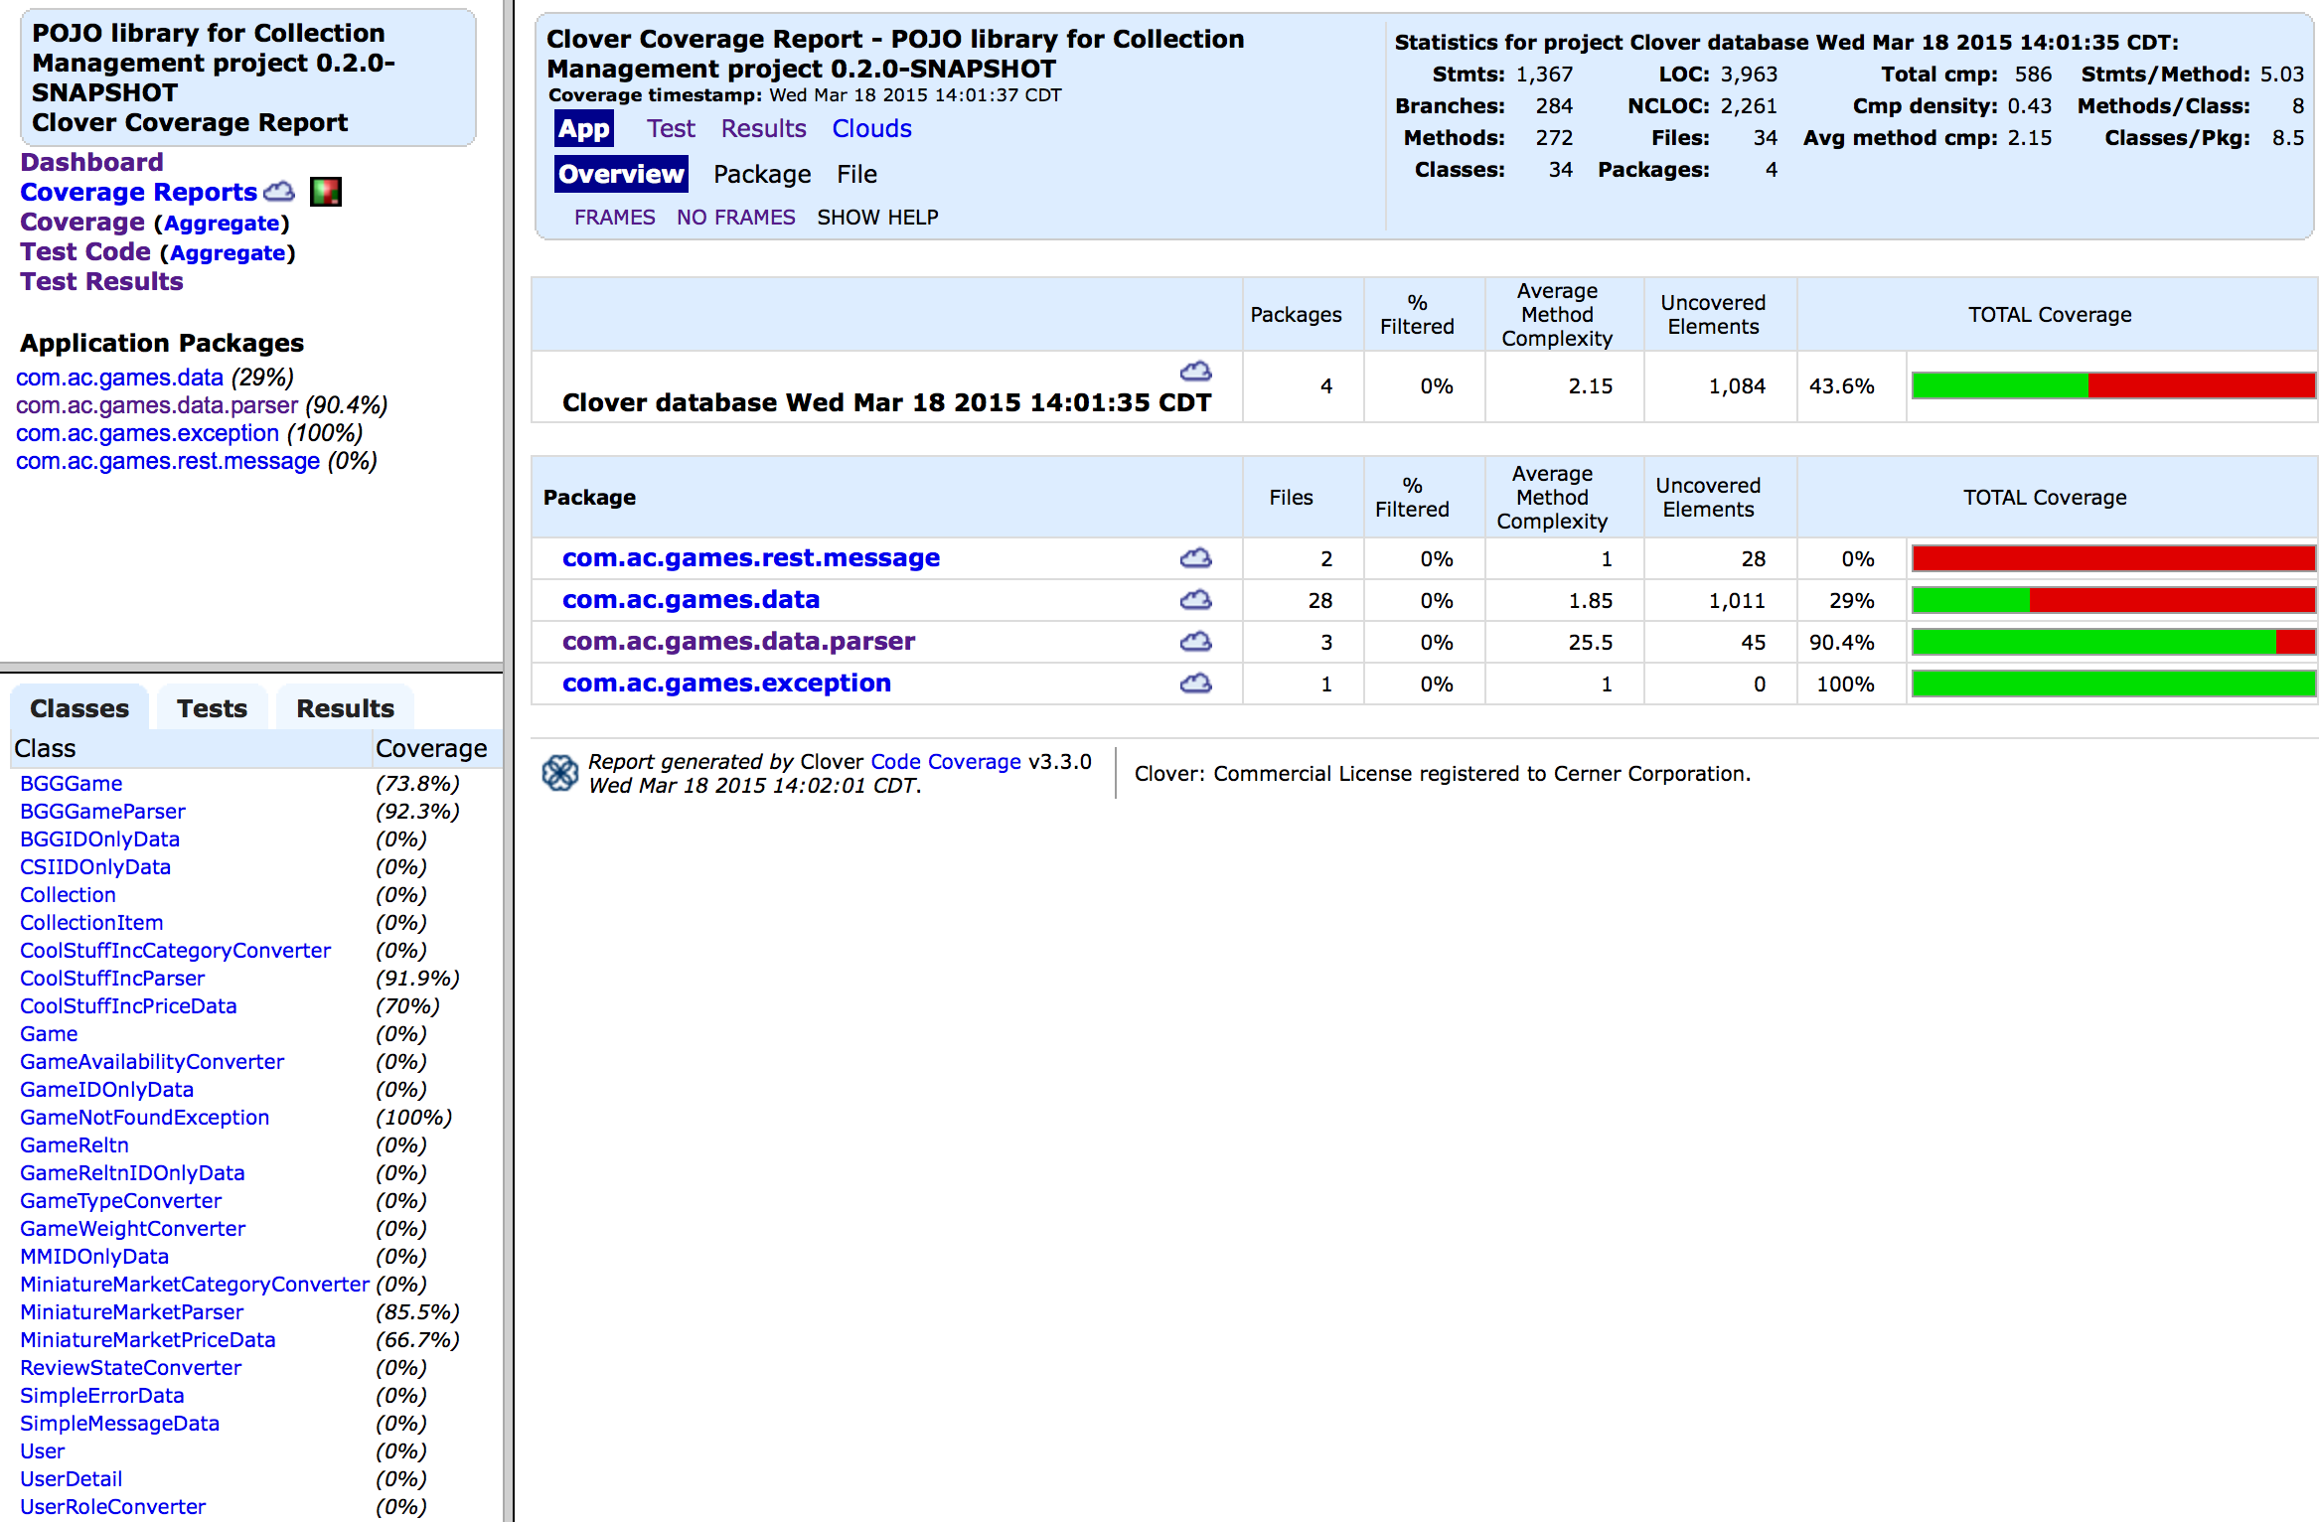

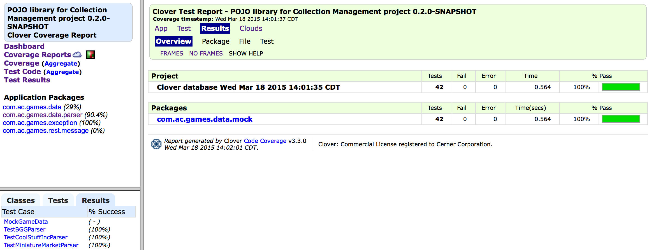

Surefire and Clover reports for this project are stored under <https://github.com/apshaiTerp/cs-5551-documentation/tree/master/maven%20sites/ac-games-pojos/ac-games-pojos-0.2.0-SNAPSHOT%20site>.

* **ac-games-db-mongo**

For this package, the same basic testing strategy was used as was done in the first iteration: Create a series of 3 objects, run a set of inserts and updates, verify that the correct results were obtained for all operations as anticipated. This was done for all new database objects.

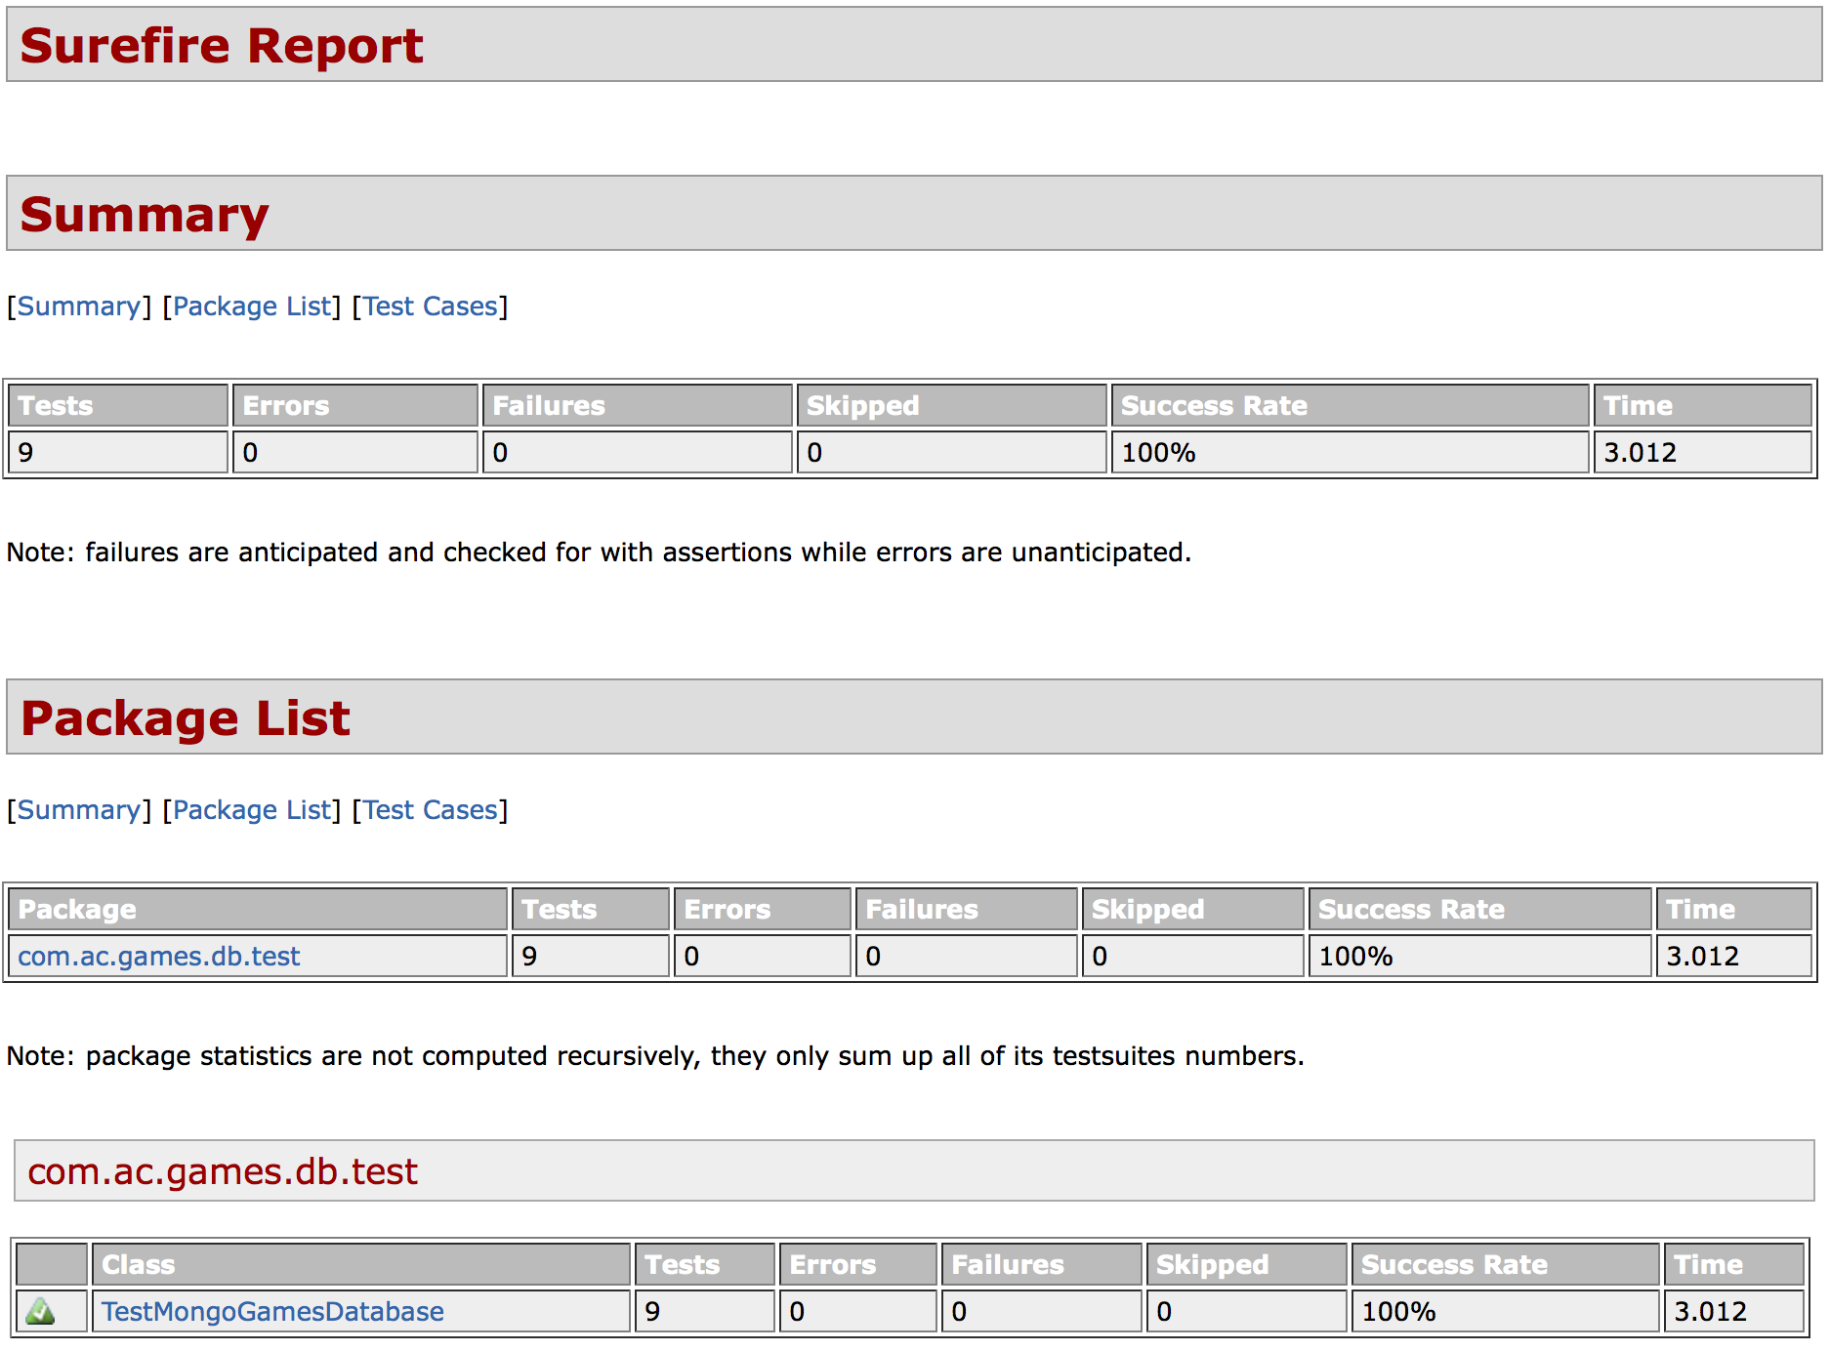

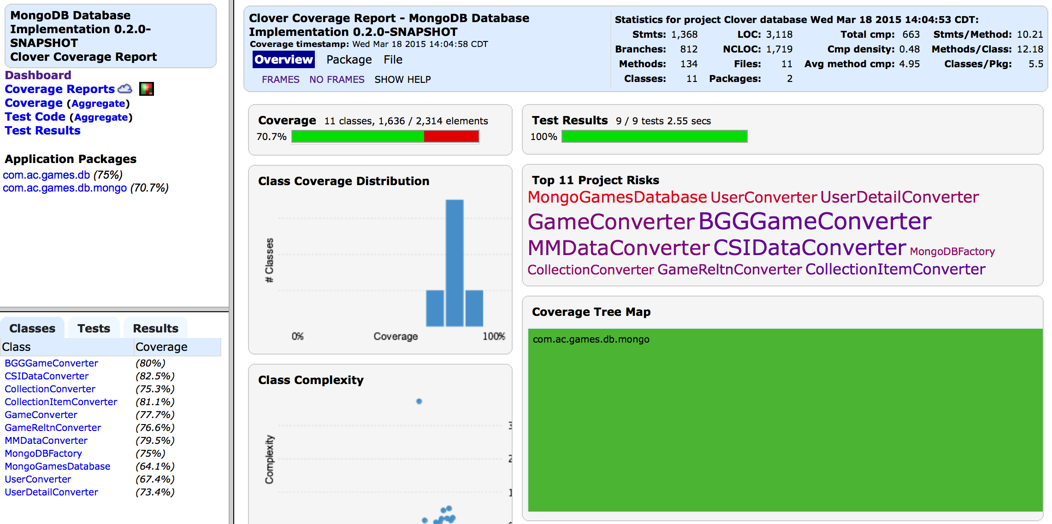

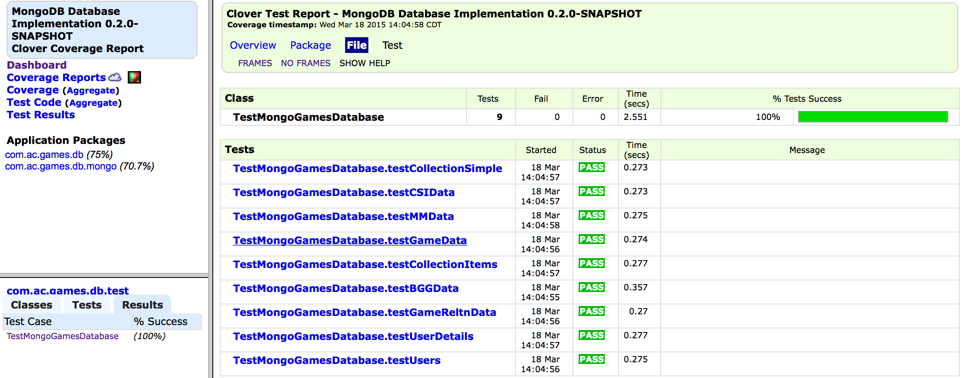

Surefire and Clover Reports for this project are stored under <https://github.com/apshaiTerp/cs-5551-documentation/tree/master/maven%20sites/ac-games-db-mongo/ac-games-db-mongo-0.2.0-SNAPSHOT%20site>.

* **ac-games-restservice-spring**

As with the first iteration, testing was implemented using the Spring Framework and the Rest Assured Mock API. Like with the first iteration, I attempted to take a single object through all the calls for that REST endpoint. This includes in more complicated cases like new user creation checking all objects created by that process.

I discovered during this process that there are some limitations to the Mock framework, especially when it comes to data validation. For example, the Rest Assured framework does not correctly process Date values. Instead of actually converting the value to a Date, it displays the millisecond value represented by that Date. This is a limitation only of the test harness, as I can verify through non-mock usage that actual Date values are being passed through the call. Another limitation is the lack of Enum handling. Several of my report objects use Enum values. The framework is automatically casting Enum values into the toString() literal value, which made initially testing some objects difficult.

Finally, a shortcoming in current test is that most of my tests demonstrate the Happy path use case, even though there is robust parameter validation and error handing in the REST controllers. It was not deemed a prudent investment of time to implement all the edge case executions as tests at this time, since I have the virtue of being the only user and developer of this system. Had this not been the case, these would have been given a higher priority. That said, the tests as implemented still are sufficient to ensure all REST-accessible methods execute as expected.

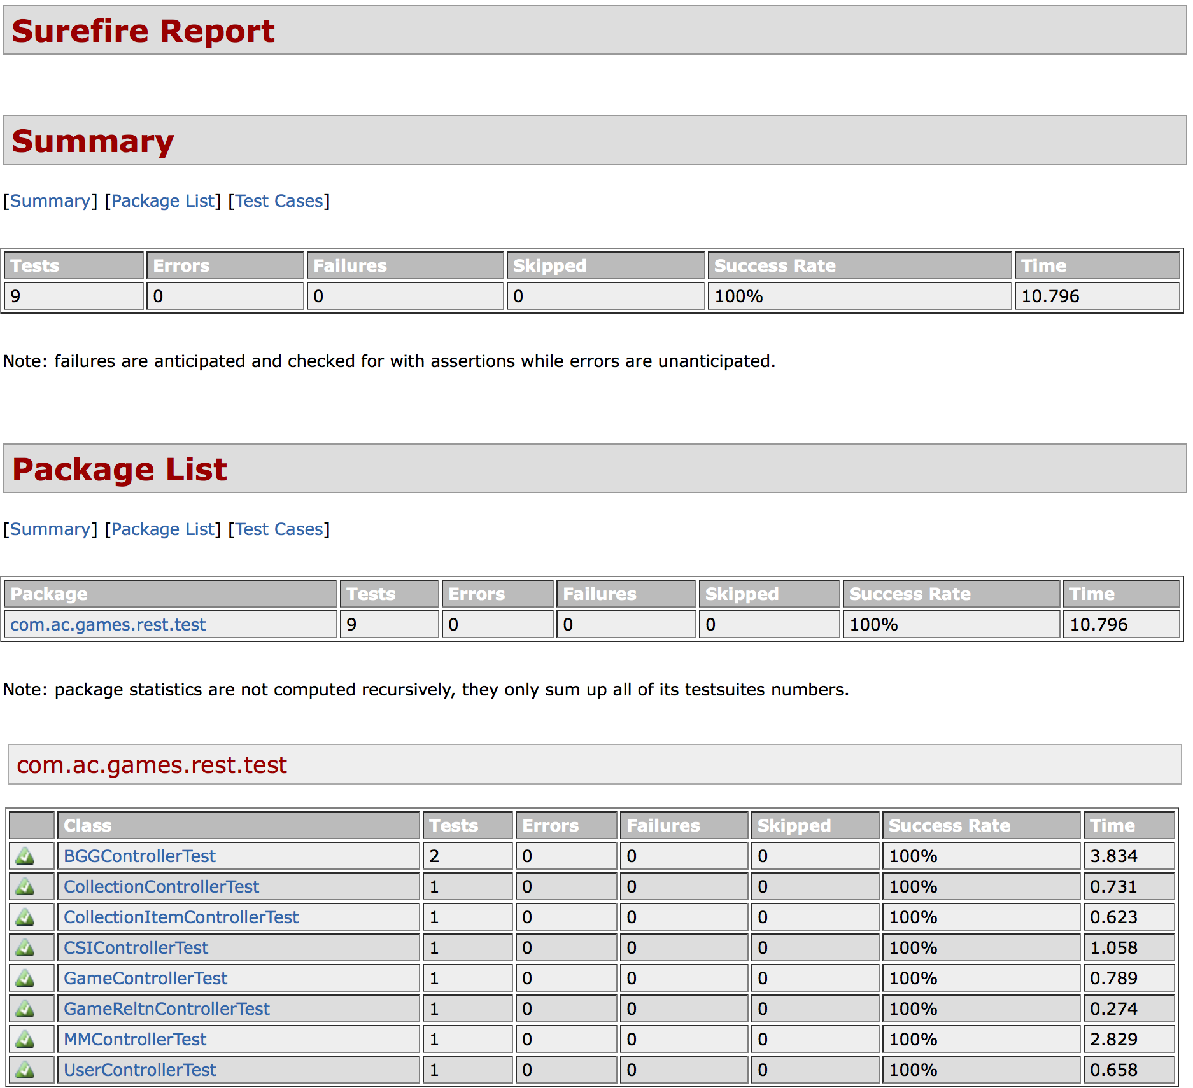

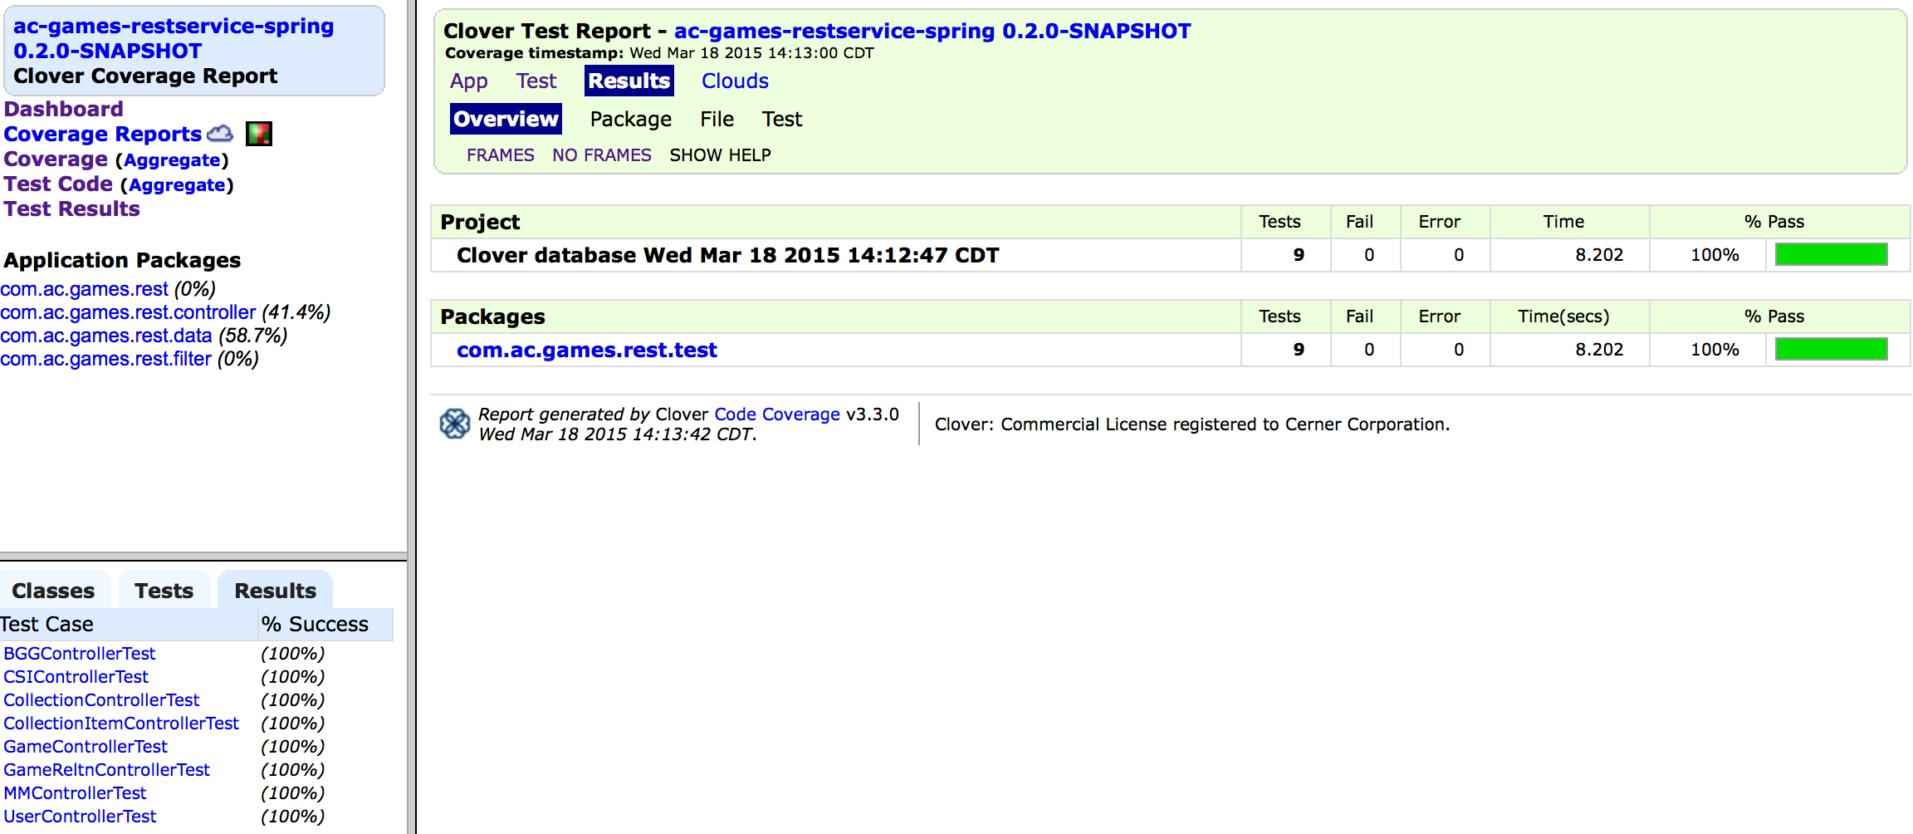

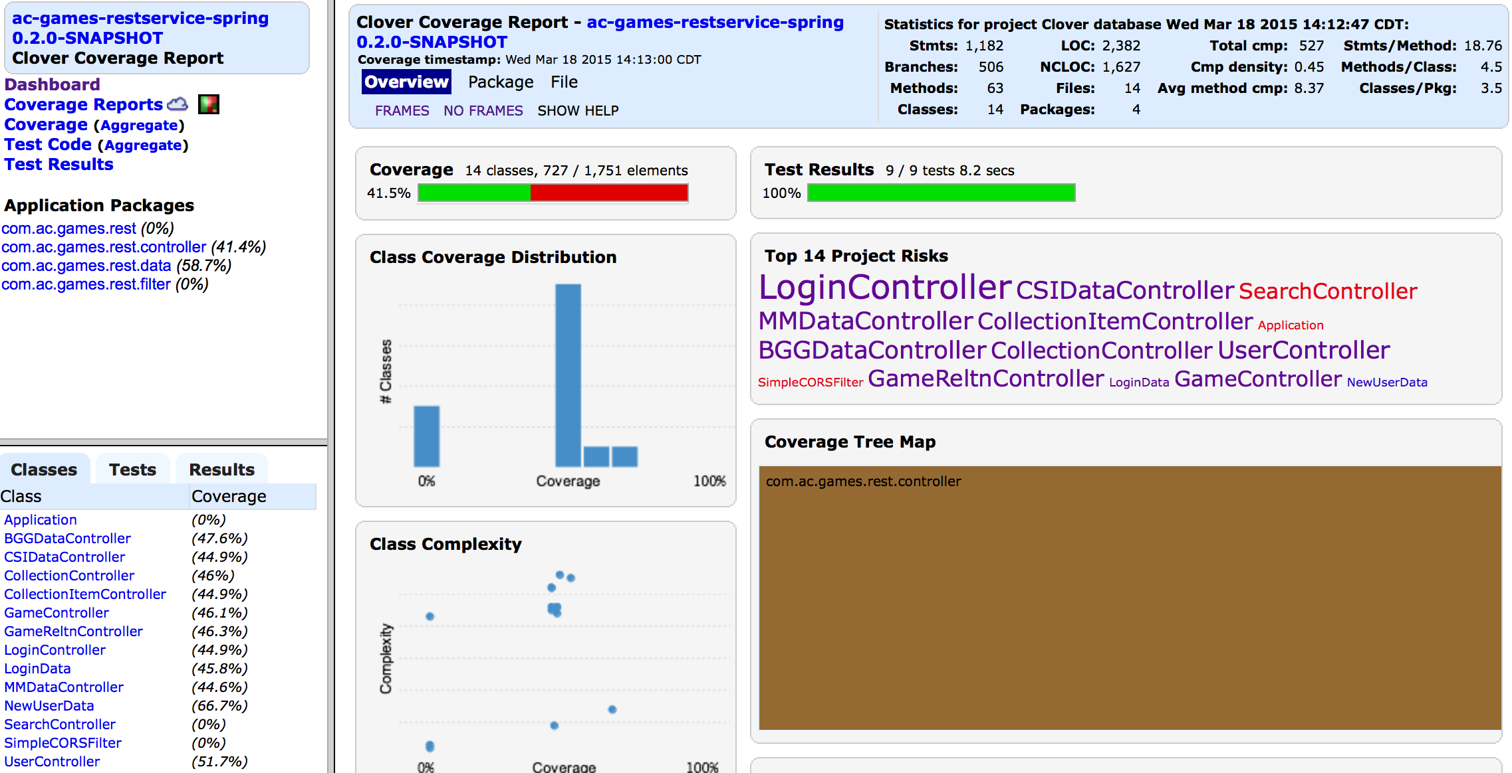

Surefire and Clover Reports for this project are stored under <https://github.com/apshaiTerp/cs-5551-documentation/tree/master/maven%20sites/ac-games-restservice-spring/ac-games-restservice-spring-0.2.0-SNAPSHOT%20site>.

1. **Deployment**

The ScrumDo link to this iteration can be found here:

<https://www.scrumdo.com/projects/project/terrapin-collection-manager/iteration/121582>

As discussed previously, there are 6 stories that were completed this iteration, and 6 more that are in-flight that will be rolled into the next iteration.

The final end-states for my projects has been included in the GitHub documentation site, but this is the list of the final java project end-states:

**ac-games-pojos-0.2.0-SNAPSHOT.jar**

**ac-games-db-0.2.0-SNAPSHOT.jar**

**ac-games-db-mongo-0.2.0-SNAPSHOT.jar**

**ac-games-restservice-spring-0.2.0-SNAPSHOT.jar**

**ac-games-agent-0.2.0-SNAPSHOT.jar**

Because I have chosen to implement my project in Java, I needed to find an alternate form of deploying my REST service and other application elements so they can be publically accessible. To this end, I used a spare computer at home to install an Ubuntu desktop, from which I am running my own MongoDB Instance and Tomcat Server. The Tomcat server hosts both my REST service as well as the web site being developed for this project.

The root URL for my service is <http://107.188.249.238/ac-games-restservice-spring-0.2.0-SNAPSHOT/>.

The URL for my site is <http://107.188.249.238/tcm/>

All screen caps for the website generated above were taken using the live site deployment.

1. **Project Management**

Because I am a team of one, I can attest that all work completed on this project is my own. While keeping track of the time spent has been difficult (I don’t track time spent, especially now that I can’t track it in ScrumDo), I would estimate that I spend about 20-25 hours weekly working on this project. I believe my code output is indicative of the time commitment I have made to work on this project.

While I remain optimistic at this point that I will complete all of the desired features and stories by the end of this project, I have had concerns that I might have overreached in my ambition. I will admit it is proving difficult to maintain this level of effort while working full time and having a second class. Part of this fear is largely due to the fact that until the last week, I have been working exclusively on framework components. This is an effort I believe will be valuable in the long run, but has at times made it difficult to gauge how much progress I was making on the application as a whole.

I believe the end of the third iteration should give a better measurement of how close I will be towards satisfying my primary goals with this application, as I hope to devote much more time to the client-side development work.

1. **References**

[1] – <https://github.com/apshaiTerp/cs-5551-documentation/blob/master/CS551-Project-Proposal.pdf> [2] – <https://github.com/apshaiTerp/cs-5551-documentation/blob/master/CS%205551%20Project%20Plan.pdf>

[3] – <https://github.com/apshaiTerp/cs-5551-documentation/blob/master/CS%205551%20First%20Increment%20Report.pdf>